Linux Commands Assignment
Name: Dnyaneshwar Tundalwar
Course: Linux Fundamentals

1. Creating and Renaming Files/Directories

Step 1: Create a directory named test_dir
Command
mkdir test_dir
Explanation
The mkdir command is used to create a new directory.
This command creates a directory named test_dir in the current working directory.
Output Screenshot:
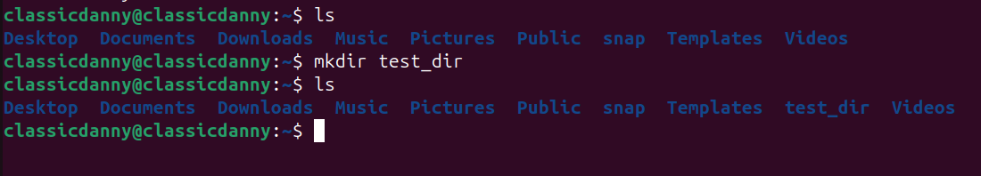

Step 2: Create an empty file inside the directory
Command
touch test_dir/example.txt
Explanation
The touch command creates a new empty file.
Here, it creates example.txt inside the test_dir directory.
Output Screenshot:
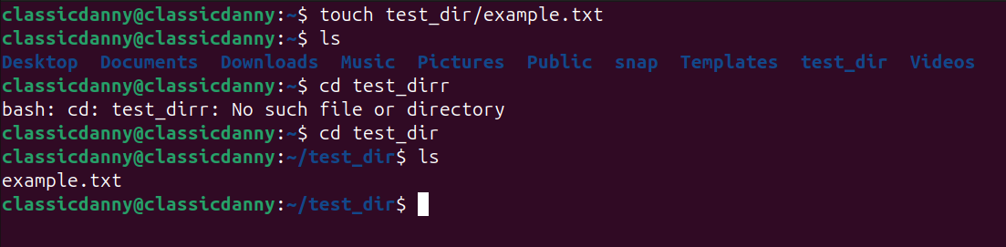

Step 3: Rename the file
Command
mv test_dir/example.txt test_dir/renamed_example.txt
Explanation
The mv command moves or renames files.
This command renames example.txt to renamed_example.txt.
Output Screenshot:
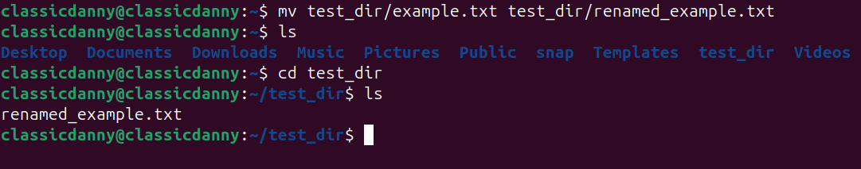

2. Viewing File Contents

Display the entire file
Command
cat /etc/passwd
Explanation
The cat command displays the entire content of a file.
/etc/passwd contains user account information in Linux.
Output Screenshot:
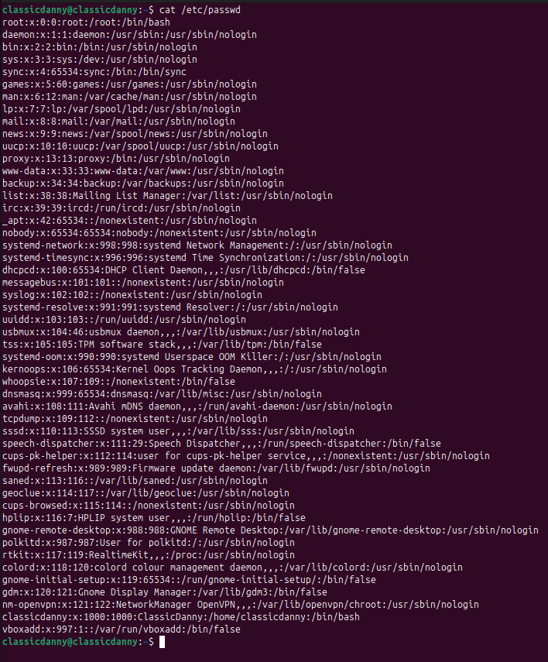

Display first 5 lines
Command
head -n 5 /etc/passwd
Explanation
The head command shows the first part of a file.
The -n 5 option displays the first five lines.
Output Screenshot:
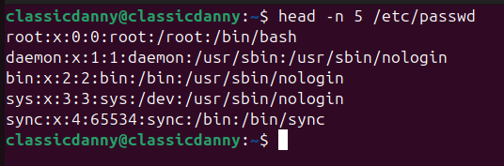

Display last 5 lines
Command
tail -n 5 /etc/passwd
Explanation
The tail command shows the last part of a file.
The -n 5 option displays the last five lines.
Output Screenshot:
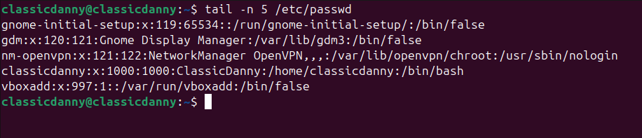

3. Searching for Patterns
Command
grep "root" /etc/passwd
Explanation
The grep command searches for specific words or patterns in a file.
This command finds all lines in /etc/passwd containing the word root.
Output Screenshot:
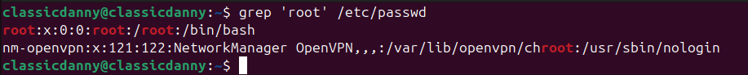

4. Zipping and Unzipping

Compress the directory
Command
zip -r test_dir.zip test_dir
Explanation
The zip command compresses files.
-r stands for recursive, which compresses the entire directory and its contents.
Output Screenshot:
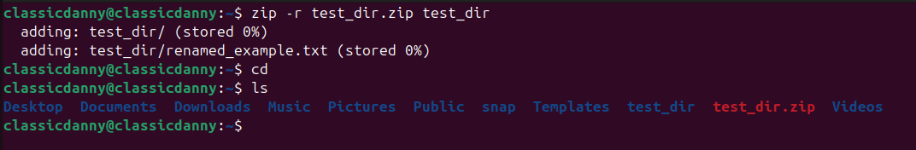

Extract the compressed file
Command
unzip test_dir.zip -d unzipped_dir
Explanation
The unzip command extracts files from a zip archive.
-d unzipped_dir extracts the contents into a new directory called unzipped_dir.
Output Screenshot:
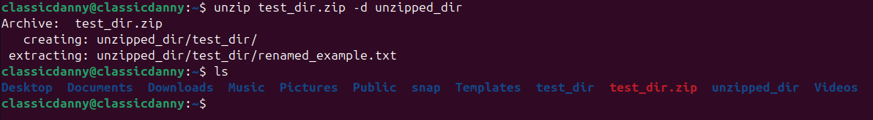

5. Downloading Files
Command
wget https://example.com/sample.txt
Explanation
The wget command downloads files from the internet using a URL.
This command downloads sample.txt from the specified website.
Output Screenshot:
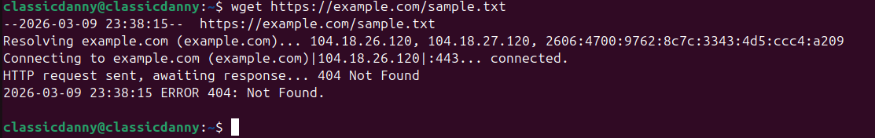

6. Changing Permissions

Create a file
Command
touch secure.txt

Change file permissions
Command
chmod 444 secure.txt
Explanation
The chmod command changes file permissions.
Permission 444 means the file is read-only for owner, group, and others.
Output Screenshot:
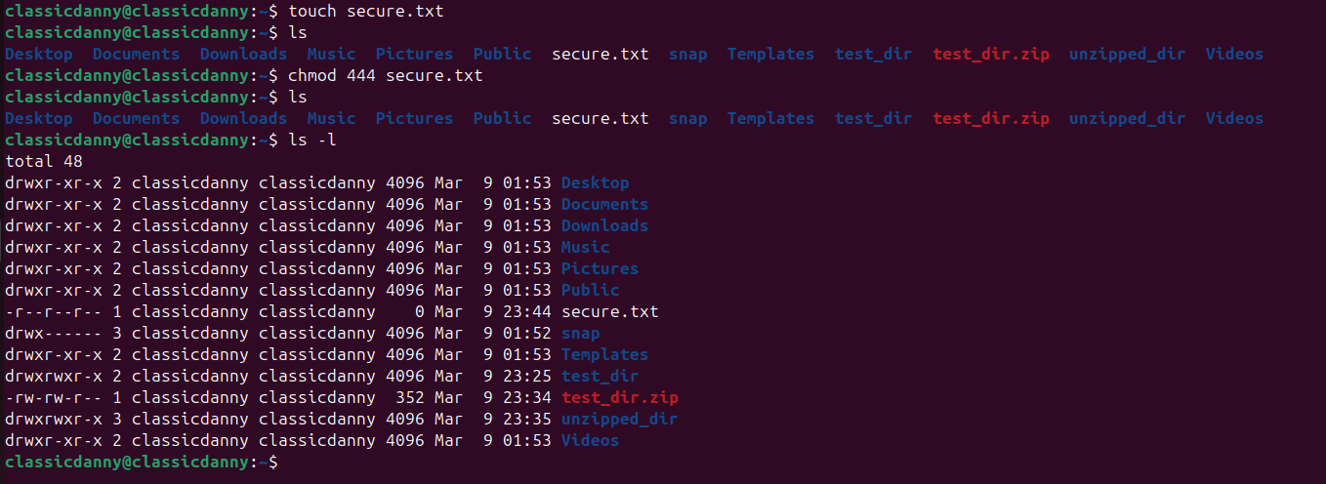

7. Working with Environment Variables
Command
export MY_VAR="Hello, Linux!"
Explanation
The export command sets an environment variable in Linux.
Here, the variable MY_VAR is assigned the value Hello, Linux!.

Verify the variable
Command
echo $MY_VAR
Output Screenshot:
